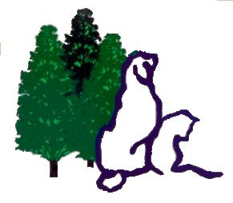
Red Cedar Animal Hospital, PC
2245 East Mt Hope Road
Okemos, Michigan 48864
Phone (517)347-0711, Fax (517)347-0714
www.redcedarvet.com

NEW CLIENT FORM

Thank you for giving us the opportunity to care for your pet(s). So that we may become better acquainted, please complete the following:
CLIENT INFORMATION
Name Spouse’s Name

Email Address Spouse's email address

Address City State Zip

Home# Mobile# Spouse# Work#

Best Way To Reach You: Call☐ Text☐ Email☐ Best Time To Reach You

Place Of Employment Occupation

Spouse’s Place Of Employment Spouse Occupation

Do you have allergies to cats or dogs? No☐    Yes☐ If Yes: cats☐ dogs☐
To provide you and your pet the best care is there any exposure to immune compromised individuals?

How did you become aware of our clinic? Drove by☐ Yellow Pages☐ Facebook☐ Yelp☐ Google☐
- Personal Recommendation (Whom may we thank?)

May we have permission to post your pet on social media? (Our company facebook page, website, etc) Yes☐ No☐
Please Fill In The Following Information Regarding Each of Your Pets
 | PET # 1 | PET # 2 | PET # 3
NAME
BREED
DATE OF BIRTH
COLOR
SEX; SPAYED OR NEUTERED?
Our pet(s) is: Member of our family☐ Child’s pet☐ Backyard pet☐
Any previous serious illnesses or surgeries? Is your pet on any special diets or medications?

Any allergies to vaccinations or medications?

Do you have pet health insurance? If yes, please list company

All Fees Are Due At The Time Services Are Rendered. 24 Hour Cancellation is required to avoid an Office Call Fee.
Please indicate today's choice of payment: Cash / Check (3% discount)☐ Visa☐   MasterCard☐ Discover☐ Care Credit☐
I herby authorize the veterinarian to examine, prescribe for, or treat the above described pet. I am at least 18, and I assume responsibility for all charges incurred in the care of this animal. I also understand that these charges will be paid at the time of release and that a deposit may be required for surgical treatment.
Signature Date

